Botanical Drawing
with Amanda Ahmed
Workshop
17-18 January 2026
QHub Auditorium
49-55 Hesse Street, Queenscliff

Workshop Description:
This two day workshop is designed for those complete newbies to drawing. The focus will be on observational drawing using graphite pencils to create realistic renderings of botanical subjects. You will explore tone, light, value, and form; experiment with different mark-making techniques; and learn how basic geometric shapes can be found in nature and translated into your drawings. The class is presented in a friendly, supportive environment and students can continue with the graphite and coloured pencil course held at the same venue during term on Thursdays (fortnightly).

Outcomes:
At the end of the workshop, you will have built up a series of sketches and studies in your drawing book and completed at least one fully rendered drawing in graphite. Subjects will be pears, leaves, and time permitting other interesting fruit/vegetables. You will develop more confidence in drawing from observation and a better understanding of graphite pencil techniques.

Workshop structure:
The following will be covered:

- Practice eye-hand coordination with a series of drawing exercises.
- Learn about other geometric tools to assist with drawing natural forms.
- Learn graphite application using different mark making and layering techniques.
- Explore tonal variances to create realistic 3D effects.

Time will be set aside to review work, provide feedback, discuss progress, and answer questions.

Materials list
Please read this carefully. Make sure all purchases are checked off list before paying for them. Do not accept cheaper alternatives other than what is listed below.
Paper - A3 cartridge paper drawing pad – must be smooth surface OR 4 sheets of A2 cartridge paper which can be cut to A3 size in class.
- A4 pad of tracing paper – nothing expensive. If you are able to purchase individual sheets of tracing paper that would be more cost effective.
- ¼ sheet Arches 300gms smooth hot pressed watercolour paper which can be purchased from the tutor for $5
Pencils - 4H, 2H, H, HB, B, 2B, 4B (Staedtler Mars – Lumograph – this is the preferred brand but if you already have graphite pencils bring those in).
Rubbers - Blue kneadable rubber.
- Good quality white rubber – e.g., Sakura Foam Rubber (purchase online); Faber Castell Dust Free,
- Tombow – mono Zero Eraser – round fine tipped pen style eraser.
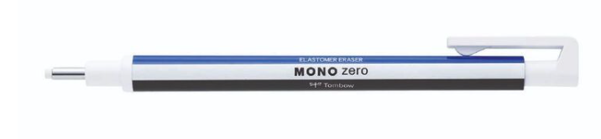
Sharpener - Students can use the tutor’s sharpeners supplied in class.
Other - Clear plastic ruler 15-20cm (measuring subject)
- Medium sized handheld magnifying glass – must have! Available at art suppliers, Officeworks, newsagents, Australia Post shops or online – don’t spend more than $15. Note: small magnifying glasses are not practical. See example below:

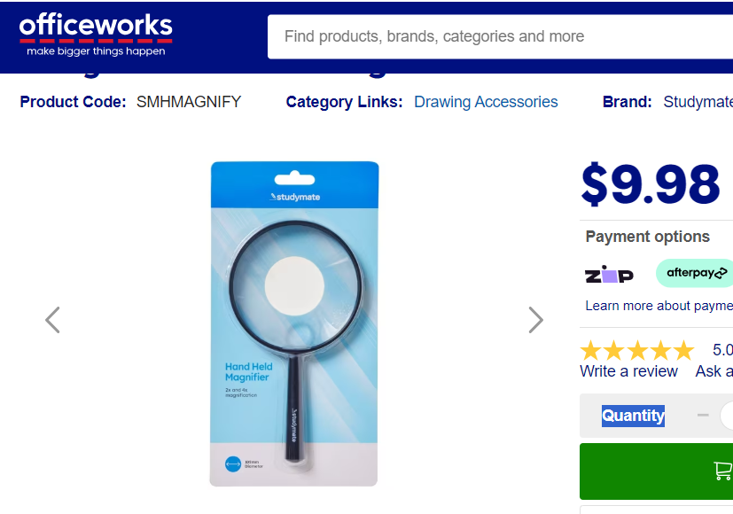

Recommended art suppliers: theartshop.com.au, Seniors, Melbourne Art Supplies. Also recommend Officeworks. Any questions regarding materials you can contact Amanda at: amanda.sidahmed@iinet.net.au.
The following will be provided by the tutor at classes:
- Pencil sharpeners
- Drawing subjects
- Black emery paper
- Stanley knife (if you already own one please bring in)
- Soldering iron stand (sounds weird but for holding subjects)
- Foamcore boards (for backdrop behind subjects)
